OOONEIDA: An Open, Object-Oriented kNowledge Economy for Intelligent Distributed Automation

Valeriy Vyatkin, Martin Luther University of Halle-Wittenberg, Germany
James Christensen, Rockwell Automation Advanced Technologies, USA
Jose L. Martinez Lastra, Tampere University of Technology, Finland
Franz Auinger, PROFACTOR Production Research, Austria

Introduction
This paper presents OOONEIDA [1], a new R&D initiative in the domain of decentralized, agile industrial control and automation for both discrete manufacturing and continuous process systems. The goal of the OOONEIDA project is the creation of the technological infrastructure for a new, open knowledge economy for automation components and automated industrial products. The new knowledge economy will be characterized by the encapsulation of different types of intellectual property (IP) present in the automation supply chain into reuseable portable software modules (function blocks), and by their application in the time- and cost-effective specification, design, validation, realization and deployment of intelligent mechatronic components in distributed industrial automation and control systems.
The initiative is supported by a number of global technology suppliers, including leading equipment manufacturers in the field of packaging, wood-working-machinery, assembly processes, etc. Leading developers of intelligent mechatronic components as well as vendors of control systems will contribute to the deployment of the technologies to be developed in the project. The participating academic and research institutions will provide the necessary fundamental research results, as well as wide dissemination of the results and training in the developed technologies. The project is open for participation of interested parties worldwide and will establish liaisons with relevant global initiatives, such as the NGMS (Next Generation Manufacturing Systems) project of the international IMS (Intelligent Manufacturing Systems) initiative.
OOONEIDA proposes that a new, open knowledge economy be constructed in the domain of distributed industrial automation and control, based on tangible benefits for all players in the value creation chain, who will be enabled to encapsulate their intellectual property (IP) into software components (function blocks) and to deploy these components into intelligent devices, machines, systems and automated factories respectively.
A major emphasis of the OOONEIDA framework will be the extensive use of modelling in industrial automation projects. The incorporation of behavioural and analytical models in automation object repositories will bring new opportunities for concurrent engineering and will be indispensable for the agile reconfiguration of production facilities. The vision of OOONEIDA is that the newly built configurations can be formally validated, thus providing significant time and cost reductions during system commissioning and testing, as well as improving the safety and reliability of production systems. Systematic modelling will be enabled through the application of standard modelling notations such as UML, suitably extended and harmonized with the architectural frameworks used in automation [8,11,13]. This will simplify the encapsulation and reuse of advanced control and computation algorithms such as model predictive control, as well as providing a basis for holistic design methodologies.
By targeting the portability, configurability and interoperability issues, the OOONEIDA framework intends to create the foundations at the control and automation level for wide deployment of intelligent production systems. It will help to improve global manufacturing competitiveness through shorter time to market and lower process life cycle costs, and to meet global market-driven requirements for short product life cycles, lower total production volumes, higher product mix, and mass customization.
The new knowledge economy of OOONEIDA will also address the legacy issues through engineering methodologies and open tools to provide migration paths from current vendor-clustered domains of locally controlled production systems, to the goal of production systems with fully open, distributed control that can be assembled or re-configured in a plug and play manner.

New Automation Market
Efficient handling of embedded intelligence is a key enabler for the agile production facilities that will be indispensable for the sustainable growth and competitiveness of production industries. The goal of the OOONEIDA project is the creation of the technological infrastructure for a new, open knowledge economy for automation components and automated industrial products. This will bring tangible benefits for all players in the value creation chain: device vendors, machine and process equipment vendors (OEMs), system integrators and industrial enterprises will be enabled to encapsulate their intellectual property (IP) into reuseable portable software components (function blocks) and to deploy these components into intelligent devices, machines, systems and automated factories respectively, as shown in Figure 1. These players will benefit further by the economies of scale resulting from the widespread application of standardized engineering methods, software tools and runtime platforms.
It should be noted that this market illustrates the characteristics of a network economy where large end-user economies of scale exist; that is, the value to each user of a technology is a rapidly increasing function of the total number of users. This creates a positive feedback mechanism that causes the market to "tip" to a new technology when a critical mass of applications, tools and understanding is developed. It is a goal of the OOONEIDA project to create this critical mass for the component-oriented development and deployment of software in the domain of distributed industrial automation and control.
The OOONEIDA project will demonstrate an architecture-centric approach to the industrial embedded systems design, based on open global standards. The project will focus on embedded software and open tools that will allow for time- and cost-effective specification, design, validation, realization and deployment of intelligent mechatronic devices in distributed industrial automation and control systems. In particular the approach will allow harmonization, integration, and re-use of the partial results obtained so far in a number of European, global and national projects such as RACKS, NOAH, OMAC, PABADIS, OSACA, OCEAN, MOVA, MOVIDA, NGMS and HMS.
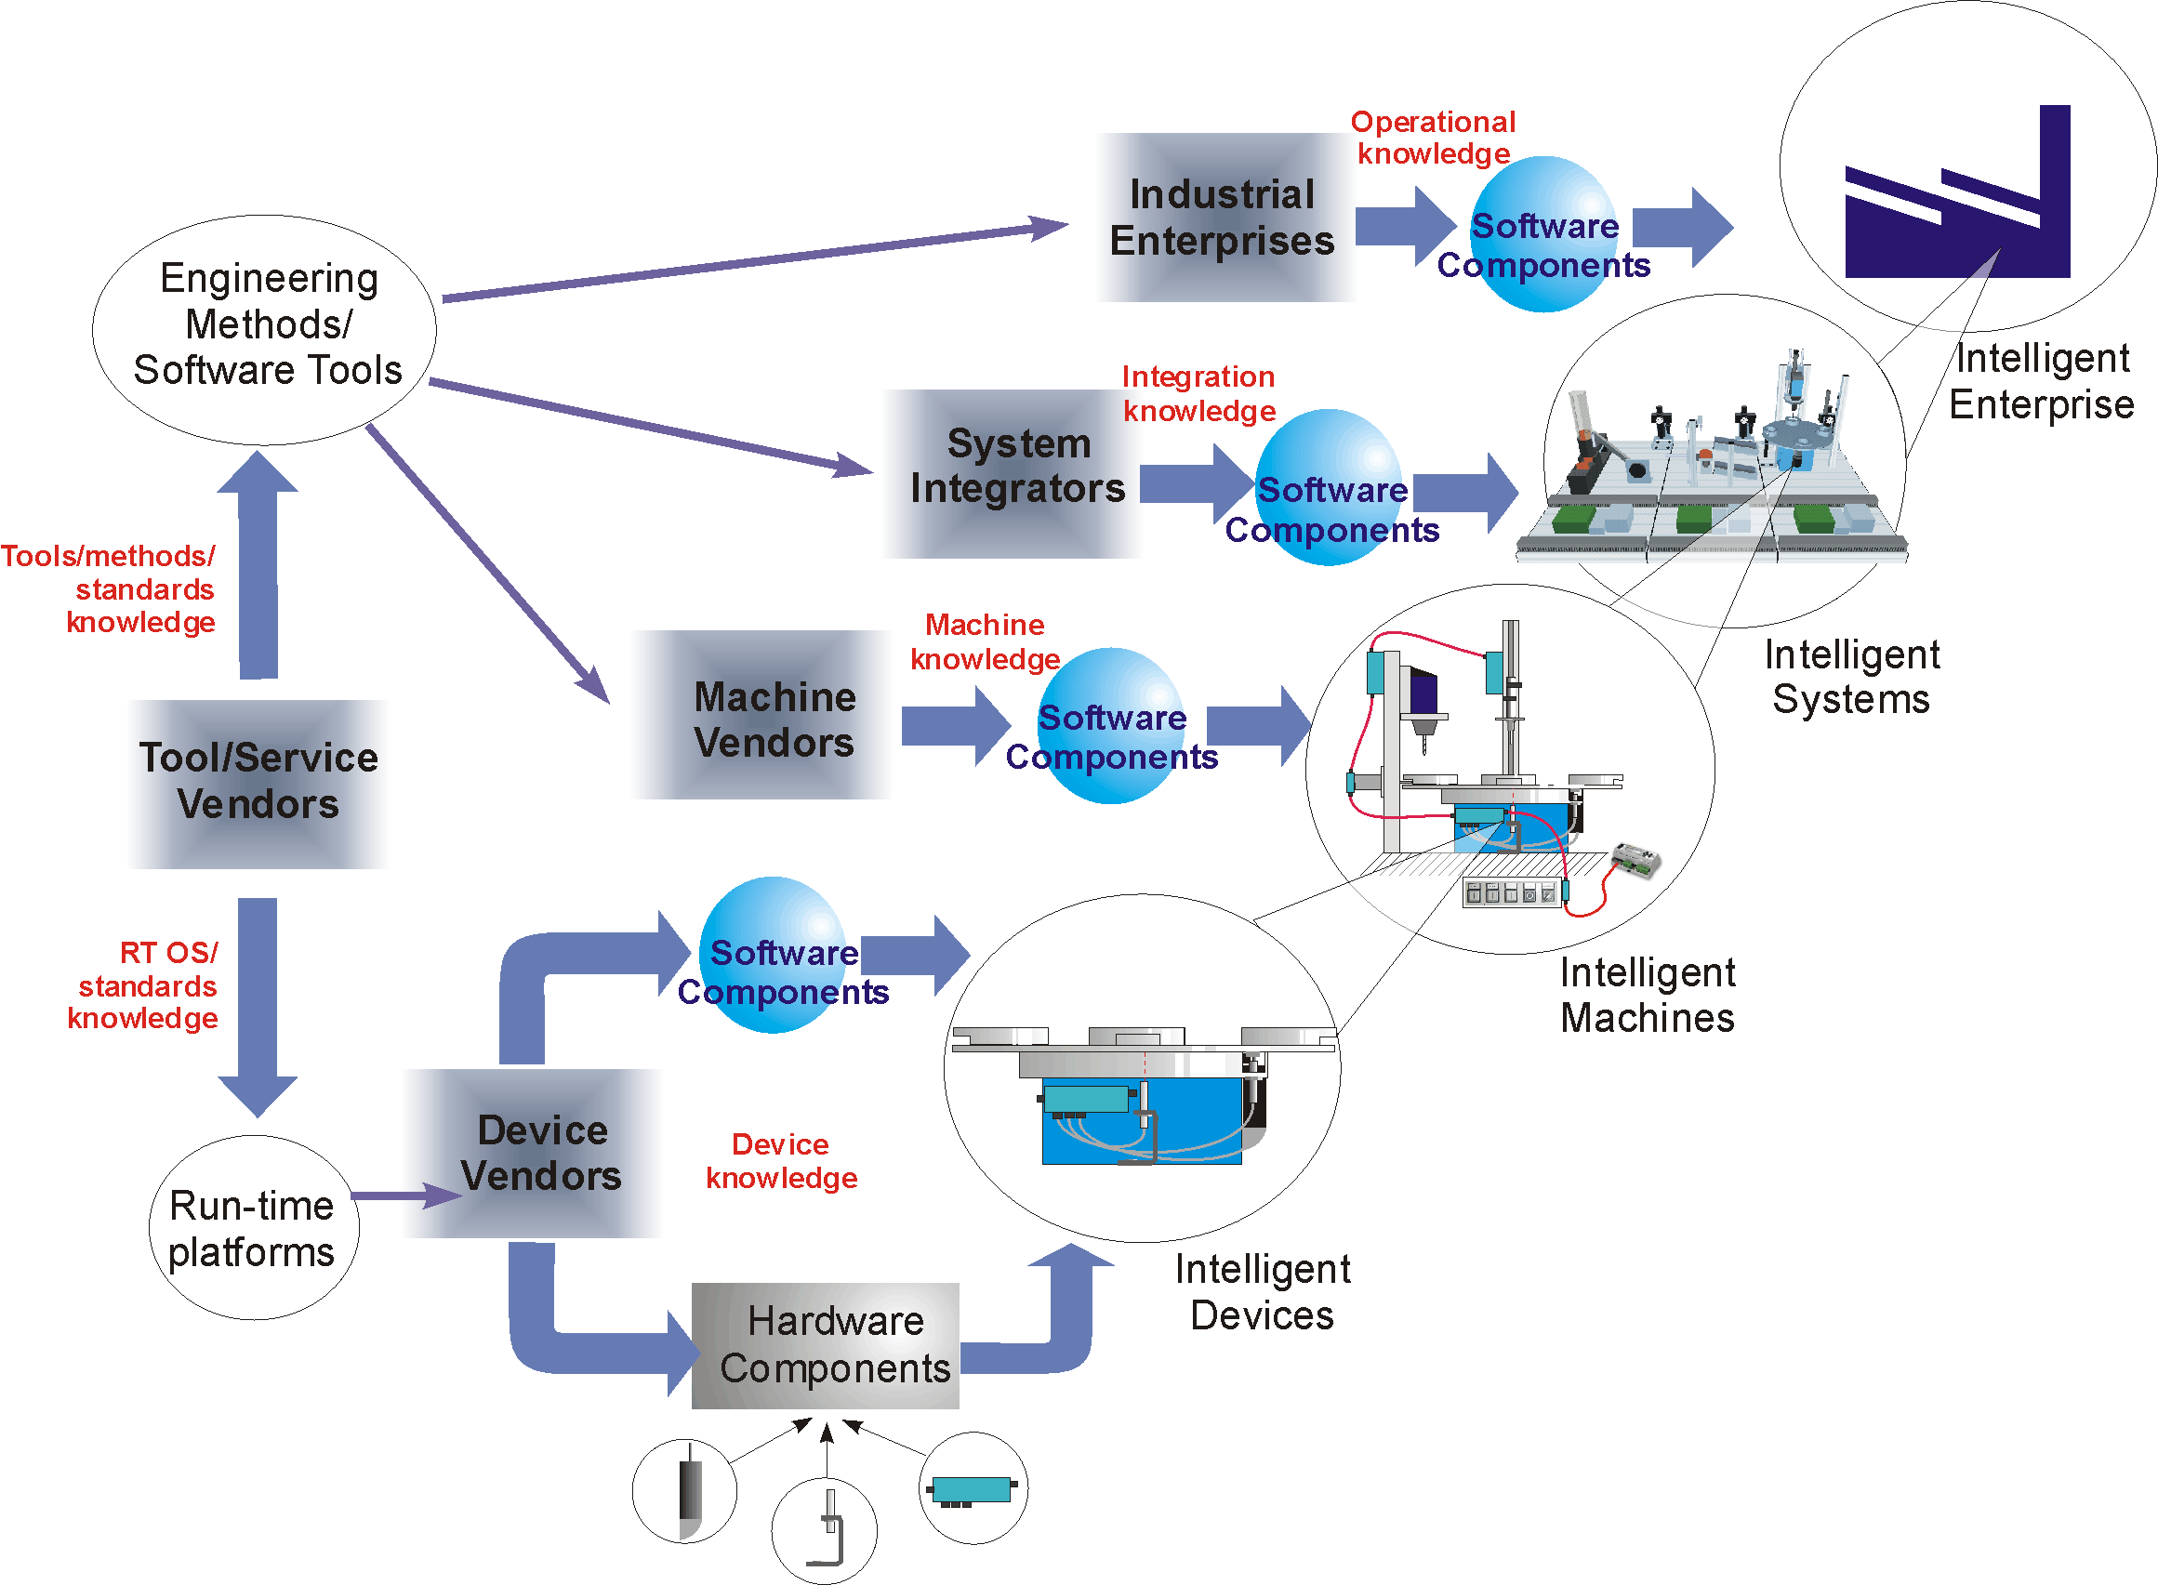
Figure 1. Value-adding chain in industrial automation.
As illustrated in Figure 2, results of the project will enable agile industrial control and automation for both discrete manufacturing and continuous process systems. The dissemination phase of the project will explore the application of the OOONEIDA engineering methodologies and tools, embedded platforms and knowledge repository technologies to broader fields of application such as embedded automotive systems, building automation, etc.

Benefits of intelligent components
The use of intelligent components and object-oriented design promise to bring essential benefits for design and re-configuration of automated production systems. These benefits account to encapsulation and reuse of a good deal of the intellectual property relevant to a particular mechanical component, machine or system. The approach being targeted in this project shifts the main focus on handling the intelligence relevant to production system instead of dealing with separate issues of mechanical, electrical, pneumatic and hydraulic integration. This way a machinery component is represented by various kinds of software components (created within a homogeneous paradigm). Thanks to such parts of the “embedded intelligence” as simulation models, HMI software, etc., such a “virtual” machine can be used even before it is implemented in metal.
Figure 2. OOONEIDA's contribution to the proliferation of agile production.
It is necessary to note that scenarios of intelligent component creation and application differ between manufacturing and process technology domains. In the manufacturing scenario, the hierarchical integration of components and encapsulation of intellectual property into corresponding software components can be more consistent, as illustrated in Error: Reference source not foundFigure 1. On either level of the hierarchy the production facility can be subject of re-configuration achieved by adding, removing or re-ordering some (physical) components.
In the process inudstries, equipment can be similarly constructed through the functional composition of intelligent components; for instance, say a reactor may be delivered with some internal pipelines and intelligent valves. However, reconfiguration rarely would be done by re-shuffling of the machines or re-piping them. Moreover, re-configuration is rarely necessary at all if the plant implements purely continuous processes, although equipment may be replaced during maintenance or for productivity reasons).
On the other hand, the trend in many branches of process industries is in development of multi-purpose plants producing batches of certain products. In this case reconfiguration is done purely on the level of “intelligence” – physical reconfiguration of the equipment is not necessary. Figure 3 shows the hierarchy of automation objects in process technologies. Intelligent devices, such as valves, motors and pumps can be equipped with their own controller hardware which runs specific control algorithms, as well as communication and diagnostic functions. Equipment, such as reactors, boilers, etc., which may include other intelligent devices, implement functions by means of corresponding software components. Intelligent systems can be built from intelligent equipment encapsulating their respective functions. The added functionality of the machine is defined by software components, which interact with the corresponding software components embedded into the constituent machines. Advanced intelligent batch systems are capable of understanding product recipes and translating them into commands for sequential controllers which operate with basic functions of the constituent machines, specifying interconnections and parameters of the encapsulated software components.
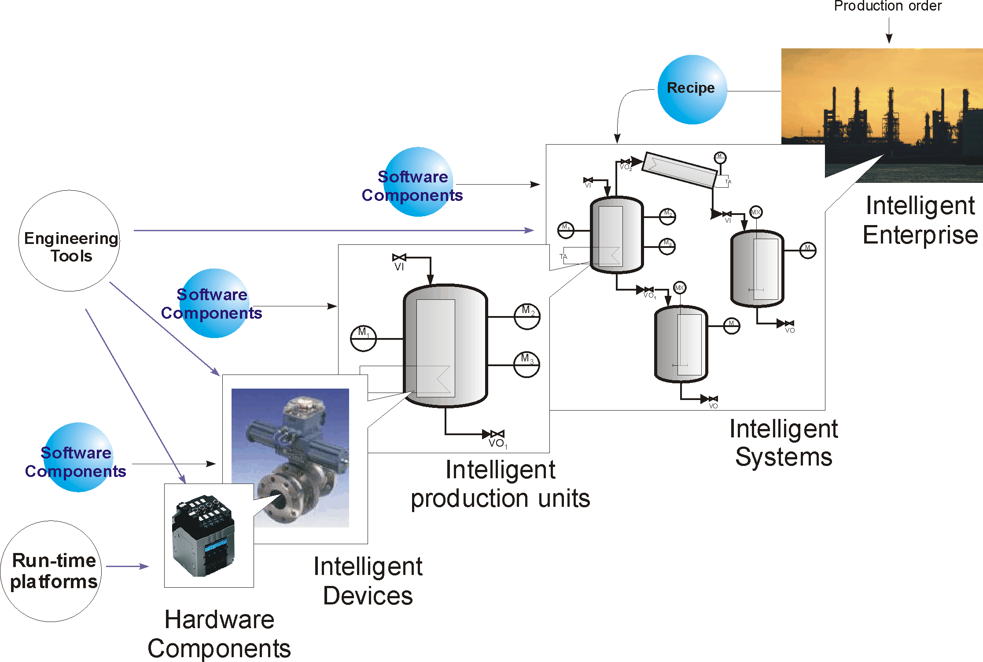
Figure 3. Hierarchy of automation objects in process technologies.

The difference between manufacturing and process technologies is in the level and degree of physical re-configuration of the equipment which may lead to different manipulations with the embedded intelligence.
Thus we observe very similar requirements to autonomous software capsules both in the manufacturing and in the process technologies. The goal of the OOONEIDA project will be to illustrate benefits and homogeneous applicability of the means for handling embedded intelligence both these technology sectors.

Architectural prerequisites
Standardization of the software architectures, network protocols, and data formats is crucial to implement plug and play integration of components from different vendors. Many of the architectural issues relevant to the internal organization of software components in distributed control systems have been answered by the new IEC61499 standard [2]. The standard bridges the gap between traditional approaches in software system engineering in industrial automation and new challenges emerging from the increasing decentralization of automation. The latter trend forces penetration of the cutting edge solutions from information technologies to the industrial environment. For instance, these are component software architectures providing seamless integration of heterogeneous software components and their interoperability via networks. However, as opposite to many other fields of applications (even those related to advanced control, as in [6]), industrial automation requires very systematic and careful approach to the re-use of existing solutions in the next generation of distributed automation systems. The following reasons set additional restrictions for the software architectures in such new systems:
- Price efficiency – embedded automation must combine high performance with low price. This limits the resources available for applications.
- Requirements for reliability in systematic exploitation are different from solutions that could be satisfactory for “single mission” applications. Among other needs, this requires simplicity and determinism of system solutions.
- Maintainability of automation systems is determined by the training level of the factory floor personal. For this reason, the human interface (which also includes the means of re-programming) should not be radically different from what is used in the field now.
The software applications for smart mechatronic components must not be sensitive to the differences in topology of execution platforms; that is, they should show an equivalent behavior when executed on distributed set of computation resources instead of a single device, or vice versa. This implies a set of requirements to platform independence and predictability of the results. In particular, the following features of IEC61499 answer these requirements:
- An atomic software unit as defined in the standard is a basic function block – a container of application algorithms and services, wrapped with execution control. The algorithms can be represented in the traditional languages for industrial automation systems.
- The connection between blocks is specified by events with associated data, which in some cases may be viewed as messages. This provides semantic independence from particular platforms.
- The atomic units can be organized in whatever complex hierarchical structures by creation of networks of interconnected blocks. The networks encapsulated in form of composite blocks may be used as building blocks in other networks, etc.
- The composite blocks may provide multiple interfaces to the outer world, depending on whom the interface is destined.
The detailed description of the IEC61499 is beyond the scope of this paper (an interested reader may refer to [3,4] for more information). The standard is currently undergoing conversion to final form from previous Publiclya Available Specifications (PASs), and naturally requires evaluation in practical projects. This work is also intended to be a part of this activity.

To minimize the effort of re-training of personnel, the “new” function blocks should provide the means to preserved and encapsulate the algorithms in currently commonly used forms of ladder logic, function block diagrams, instruction list language, and sequential function charts, as illustrated in Figure 4. The usual semantic of these languages on the one hand has to be combined with distributability and device independence on the other.
Figure 4. Encapsulation of traditional forms of IA-intelligence into portable function blocks.
Moreover, migration paths have to be provided in order to re-use the software components deployed in the field so far for development of new portable and distributable function blocks.

IT Infrastructure for the New Knowledge Economy
It is apparent from the previous discussion that the value created by each player in the chain is based on the knowledge of how to apply the encapsulated IP available from previous links in the chain, typically by integrating components from the preceding links with components encapsulating the player's own knowledge. For instance, machine vendors add value by integrating hardware and software components from device vendors with their own value-adding hardware and software.
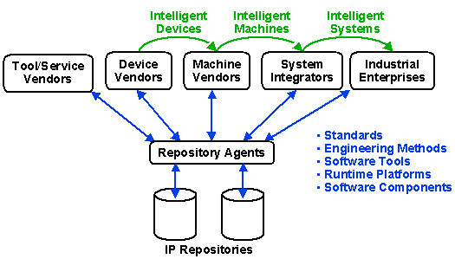
Figure 5. Repository agents as the cornerstone of the new knowledge economy in industrial automation.
OOONEIDA proposes the development of an IT infrastructure to support this knowledge economy as illustrated in the following figure. A set of searchable Intellectual Property (IP) repositories is envisioned in which each player deposits his own encapsulated IP along with appropriate descriptive information to facilitate searching by intelligent repository agents. These agents enable "downstream" actors to find appropriate encapsulated IP from "upstream" actors to meet their functional requirements. The agents then arrange to make the functional capabilities of the encapsulated IP available under appropriate licensing and payment arrangements. Thus, the repositories and their associated agents comprise a set of value-creating knowledge-based services.
The IT infrastructure of OOONEIDA can be viewed in more detail as consisting of three domains:
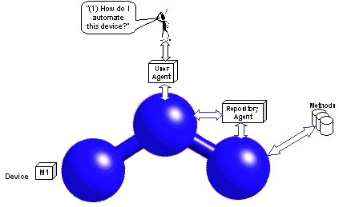 | 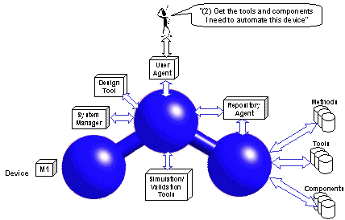
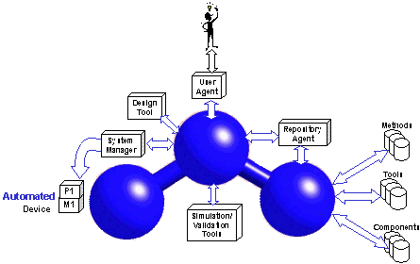 | 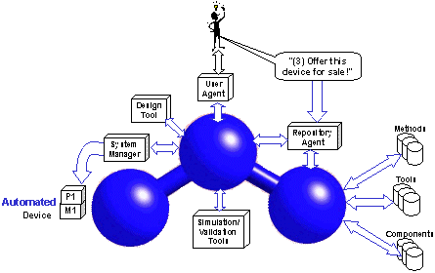

- The open physical domain, utilizing open, interoperable intelligent mechatronic elements based on the IEC 61499 standard for the use of software modules (function blocks) for industrial process measurement, control and automation.
- The open tools domain, based on a publicly available, open software tool integration platform such as Eclipse or NetBeans.
- The open repository domain, consisting of distributed repositories for standards, engineering methodologies and their supporting software tools, runtime platform implementations and software components. Systematic indexing and searching of these databases will be supported through appropriate adaptation of a proposed standardized notation for “Automation Objects”.
These domains are "open" as defined in part 4 of the IEC 61499 standard; that is, they support interoperability of control/automation platforms, software tools and repositories; portability of software elements within and between domains; and configurability of platforms by tools. Since this infrastructure consists of three open, object oriented domains, it will be referred to as the O³ infrastructure.
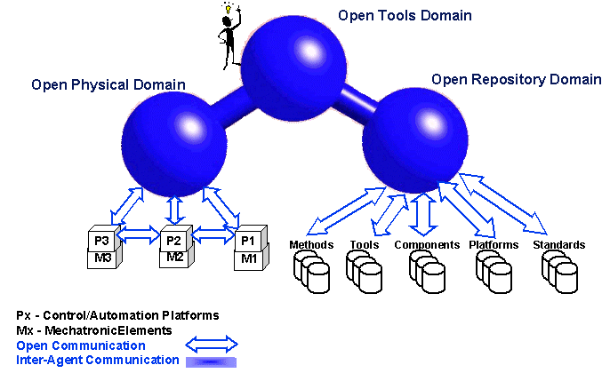
Figure 6. The IT infrastructure of the OOONEIDA initiative.
As shown in the figure above, the main avenue for human interaction with the O³ infrastructure is the tool domain. The user is supported by two major classes of agent: (1) the user agent which supports his interaction with the tool domain, and (2) the repository agent which facilitates indexing and searching of the repository domain. A typical scenario for the use of the infrastructure, in this case by a device vendor, is illustrated below. Similar cases can be constructed for the use of the infrastructure by other actors in the knowledge economy.

Integration and Re-configuration of Production Systems built from “Intelligent” Objects
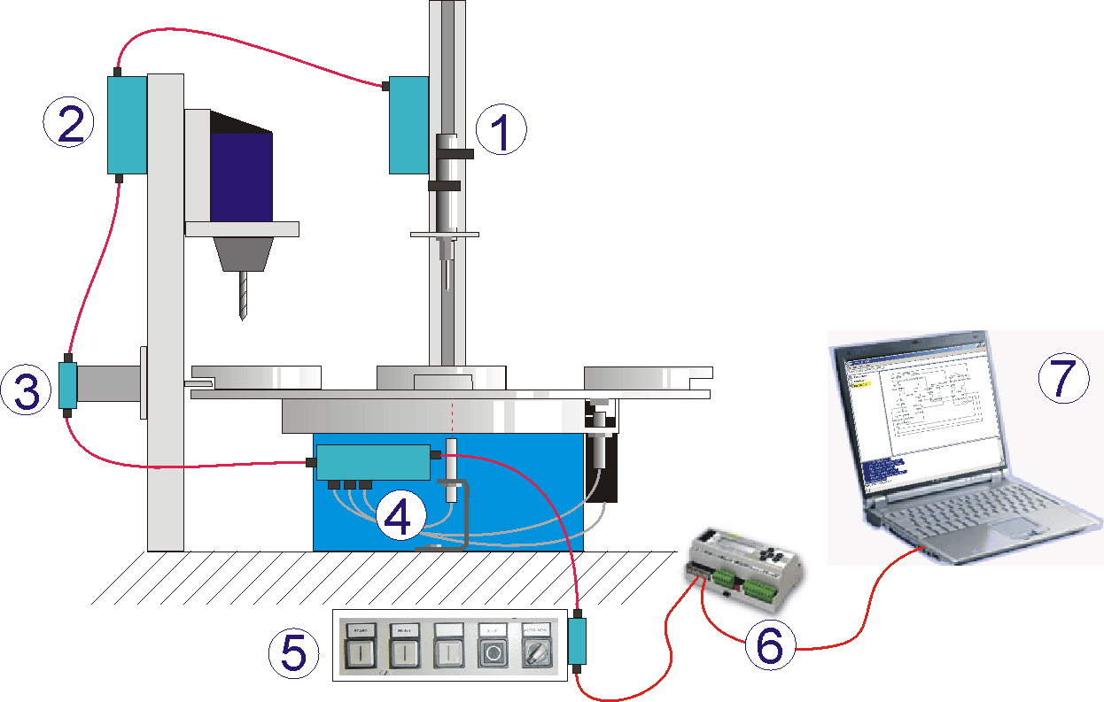
Figure 8. The modular system assembled by “plug and play” of smart mechatronic components: 1) Table; 2) Clamp; 3) Drill; 4) Checker; 5) HMI panel. In addition the system has: 6) Control device 7) Engineering station.

Reconfigurable manufacturing systems (RMS) [5] is an approach to provide cost effective means for production to order as different to the flexible manufacturing systems (FMS), which are based on universal machines. Reconfigurable machines rely on free combination of their constituent subsystems. As the machines are heavily embedded with automation hardware and software, the efficiency of the reconfiguration largely depends on the efficiency of the corresponding information and software technologies.
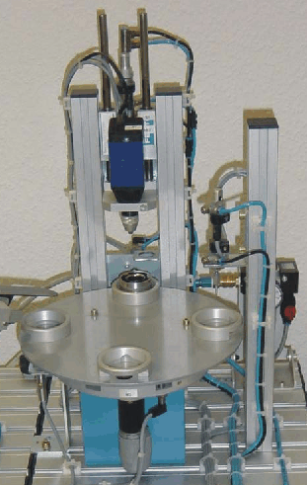
Figure 7. Part of a modular production system built from “mechatronic components”.
To study the problems which the integration of reconfigurable machines may be facing, let us consider an example of a modular model of production system (Figure 7), that consists of a rotary table with 4 slots for workpieces, a drill, a device measuring quality of the drilling (checker), and a clamp preventing rotation of the table during the drilling and measurement operations. One may clearly distinguish 4 “mechatronic objects” in this system: table, drill, checker and clamp. In addition, there is a human machine interface panel with several buttons, switches and LEDs.
For the testbed we took a commercially available FESTO modular processing unit originally intended to be controlled by a single programmable controller. Since the constituent components were not equipped with their own embedded controllers we have used a Netmaster hardware device (a make of Italian company Elsist) that is a mini-controller with analog and discrete I/Os and TINI microprocessor – a hardware implementation of the Java virtual machine. One Netmaster was taken to control the whole system. For execution of function blocks we used FBRT from Rockwell Automation – a Java based run-time included in the experimental software toolset supporting IEC61499, which runs both on PC and on Netmasters thanks to the platform independence of Java. The other part of the toolset is Function Block Development Kit (FBDK) – the engineering software tool. A PC was used as an engineering station, as well as for allocating human-machine interface, and for rendering of process. PC and Netmaster were connected via Ethernet.
An evident requirement to the organization of smart building blocks for reconfigurable systems is encapsulation of hardware and software issues. Thus, instead of wiring all sensors and actuators to an external control device, all the wiring can be done to the embedded control device, which, in turn, may provide further access to these data via network. This shall minimize physical efforts on building the components into a system – it would be enough to interconnect the automation objects with a single network wire to provide transparent access from all components to the data of each other. Figure 8 shows the mechatronic view on the testbed. All the components have small grey boxes, schematically representing their embedded control devices. The boxes are connected by a single network wire which may also be extended to additional computation resources as needed (e.g. additional control devices or engineering stations).
Basic operations of the components may be pre-programmed by its vendors and encapsulated in form of software blocks, thus providing a higher-level interface to the functionality of the mechatronic unit. The encapsulated issues may deal with complex control dynamics that requires special expertise of the unit developer. On the other hand, a direct interface to the sensors/actuators can be also provided to not restrain the abilities of the customer.
To integrate smoothly the software components contained in different mechatronic units into a single system, they shall comply with common semantic rules. In addition, compatible and interoperable tools and run-time platforms are required. If the software functions were properly encapsulated and organized in a single architectural framework, they could be efficiently integrated into decentralized control of the system.
In Table 1, two scenarios are shown for system engineering of machines built from intelligent components. A prospective engineering tool (e.g. such as CORFU [12]) would allow design of the software of systems by interconnection of pre-programmed components and their allocation to available devices in a visual manner.
Step | Scenario 1 (physical integration) | Scenario 2 (virtual)
1 | Specify the requirements to the production facility, identify necessary technological operations and the physical actors capable of implementing them.
2 | Obtain the actors as mechatronic components from their vendors; | Obtain the “intelligent part” of mechatronic components (i.e. software components and data) from their vendors – the components may not physically exist at this moment.
3 | Design the system using a CAD software tool  importing profiles of the components (delivered together with them).
4 | Assemble the system from the components
5 | Interconnect the embedded controllers of components with a network to each other and to external control devices and to a PC-based engineering station;
6 | Configure the system from the engineering station:
7 | Find all the components connected to the station scanning the network segments; | Create the desired configuration of devices using the repository of available device types (e.g. included in the software components).
8 | Open each component and configure it by populating the resources of the component’s computational device by sub-applications built from the appropriate function blocks, interconnect them and set the parameters;
9 |  | If necessary, create a simulation configuration using the device types executable on the engineering station)
10 | If necessary, design a higher-level supervisor to orchestrate operation of the system and provide interface to the higher-levels of automation systems representing the system as the whole entity.
11 | Allocate execution of the developed sub-applications to the available range of devices. For example, if the computational capacity of the embedded control device allows, it might be possible to allocate the supervisor to one of these. Otherwise, an additional control device might be added to the network. Provided that all devices are compatible to the extent, the blocks shall be executable anywhere.
12 | Run system | Conduct simulation of the system
13 |  | Transition from the simulation scenario to the real system would consist in changing the simulation configuration to the real configuration of devices.
14 |  | Implementation: go to the step 4 of the first scenario.
Table 1. Scenarios of system engineering using smart mechatronic components.
The virtual scenario is a complement to the main scenario based on the physical plug-and-play integration and configuration of the system. It can be applied to conduct engineering of production systems concurrently with the design of their components. Thus several iterations with the “virtual component” may prove its properties, as well as properties of the system.

Structure of Intelligence in Automation Objects
The collection of data and software components relevant to a particular mechatronic object forms its intelligence repository. It may be located even in the memory of the embedded control device, or on any other media, including the Internet (say on the web-site of the component’s vendor). Once the repository is opened, the user might see the structure as exemplified in Figure 9 for the DRILL component.
If the component is equipped with an embedded controller, its profile shall be also contained in the repository in form of device type. The latter is identified by device class (IEC61499 distinguishes classes 0,1 and 2 – ordered by scale of supported functionality), supported functions (determined by available libraries of function blocks), and by types of supported resources. InFigure 9, the functions and data related to the device are located in the first, upper part.
The lower part contains the blocks encapsulating the functionality of the mechatronic component. The functional domains of the embedded intelligence may include (but not limited to): control, visualization, diagnostics, simulation, implementation of human-machine interfaces, etc.
The structure of the repository in Figure 9 evolves from the engineering patterns described in [3]. In particular we tried to combine Model-View-Controller, proxy, automation objects and agent patterns. In addition to the repository capacities, a device (depending on its class) may allow creation of resources instantiating them from the available resource types, or may contain a fixed number of resources. The resources serve for the execution of function blocks.
The basic blocks are device-independent containers of algorithms operating on the object’s data as defined by adapter interfaces. The composite blocks rely on the basic ones, and provide binding with particular device types using some of their service interfaces. Thus, process interface blocks implement mapping from adapter interfaces to/from process data by means of service interfaces. The agents integrate basic functional elements with interfaces to the environment. The communication proxies implement the exchange of adapter interfaces between devices by means of communication interface FBs. Thus they may represent an actual agent in connection with its counterpart. The communication proxies combined with agents and some function blocks implementing the reasoning form so called autonomous agents. An example of an autonomous agent is an “embedded agent” that polls the process data and makes them available to other agents via network services.
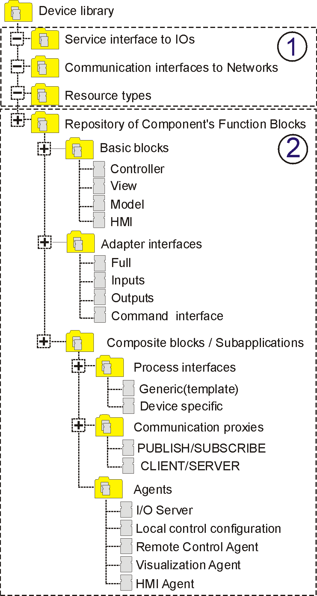
Figure 9. Structure of the intelligence repository of the automation object DRILL: 1) blocks specific for an embedded control device; 2) blocks encapsulating functionality of the DRILL.
The testbed and lessons learned during its development are considered in more details in [9].

Conclusion
Started as an activity around IEC61499 standard development, the OOONEIDA initiative paves the way for the industrial sectors which could benefit most from the creation of the new knowledge economy in automation, namely to the vendors of automated equipment and its components. Thus, OOONEIDA pursues the very practical goal of facilitating the design of new machines and production systems.
On the other hand, the conducted analysis shows that the framework intended to be created enables application of the most advanced methods of work planning on the shop floor level, such as agent-based manufacturing execution systems.
Thus, OOONEIDA answers challenges that have already emerged in the automation field, as well as those that will inevitably appear in the longer run.

References
[1] OOONEIDA official web site: www.ooocean.org
[2] IEC Technical Committee TC65/WG6, “IEC61499 Industrial-Process Measurement and Control –Specification”, IEC Draft 2000.
[3] J.H. Christensen: IEC 61499 ARCHITECTURE, ENGINEERING, METHODOLOGIES AND SOFTWARE TOOLS, 5th IFIP International Conference on Information Technology for BALANCED AUTOMATION SYSTEMS In Manufacturing and Services, Proceedings, Cancun, Mexico, September, 2002
[4] R. Lewis, Modeling control systems using IEC 61499, The Institution of Electrical Engineers 2001
[5] Koren, Y., Heisel, U., Jovane, F., Moriwaki, T., Pritchow, G., Van Brussel, H., Ulsoy, A.G.: “Reconfigurable Manufacturing Systems,” CIRP Annals, 1999, Vol. 48, No. 2.
[6] B.S.Heck, L.M.Wills, G.J.Vachtsevanos: Software technologies for implementing reusable, distributed control systems, IEEE Control Systems Magazine, February, 2003, pp.21-35
[7] Marcello Bonfè and Cesare Fantuzzi: “Design and Verification of Industrial Logic Controllers with UML and Statecharts”, submitted to the IEEE Conference on Control Application 2003, June 23-35, Istanbul,Turkey.
[8] B.Selic and J.Rumbaugh,“Using UML for complex real-time systems.” Rational Software Corporation,www.rational.com/media/whitepapers/umlrt.pdf.
[9] Vyatkin V.: Intelligent Mechatronic Components: Control System Engineering using an Open Distributed Architecture, submitted for IEEE Conference on Emerging Technologies in Factory Automation (ETFA'03), Lisbon, September, 2003
[10] IEC SUB COMMITTEE No. 65C: “IEC1804 General Requirements”, IEC Draft 1999.
[11] K. Thramboulidis, “Using UML for the Development of Distributed Industrial Process Measurement and Control Systems”, IEEE Conference on Control Applications (CCA), September 2001, Mexico.
[12] K. Thramboulidis: Development of Distributed Industrial Control Applications: The CORFU Framework, 4th IEEE International Workshop on Factory Communication Systems, August 2002, Vasteras, Sweden, http://seg.ee.upatras.gr/corfu
[13] J. Rumbaugh, I. Jacobson, G.Booch, “The UML Reference Manual”, Addison Wesley 1999.
[14] The Holobloc webpage, http://www.holobloc.com
[15] IEC TC 65, Working draft – Automation Objects

